
MARIA KARLA L. GONZALES
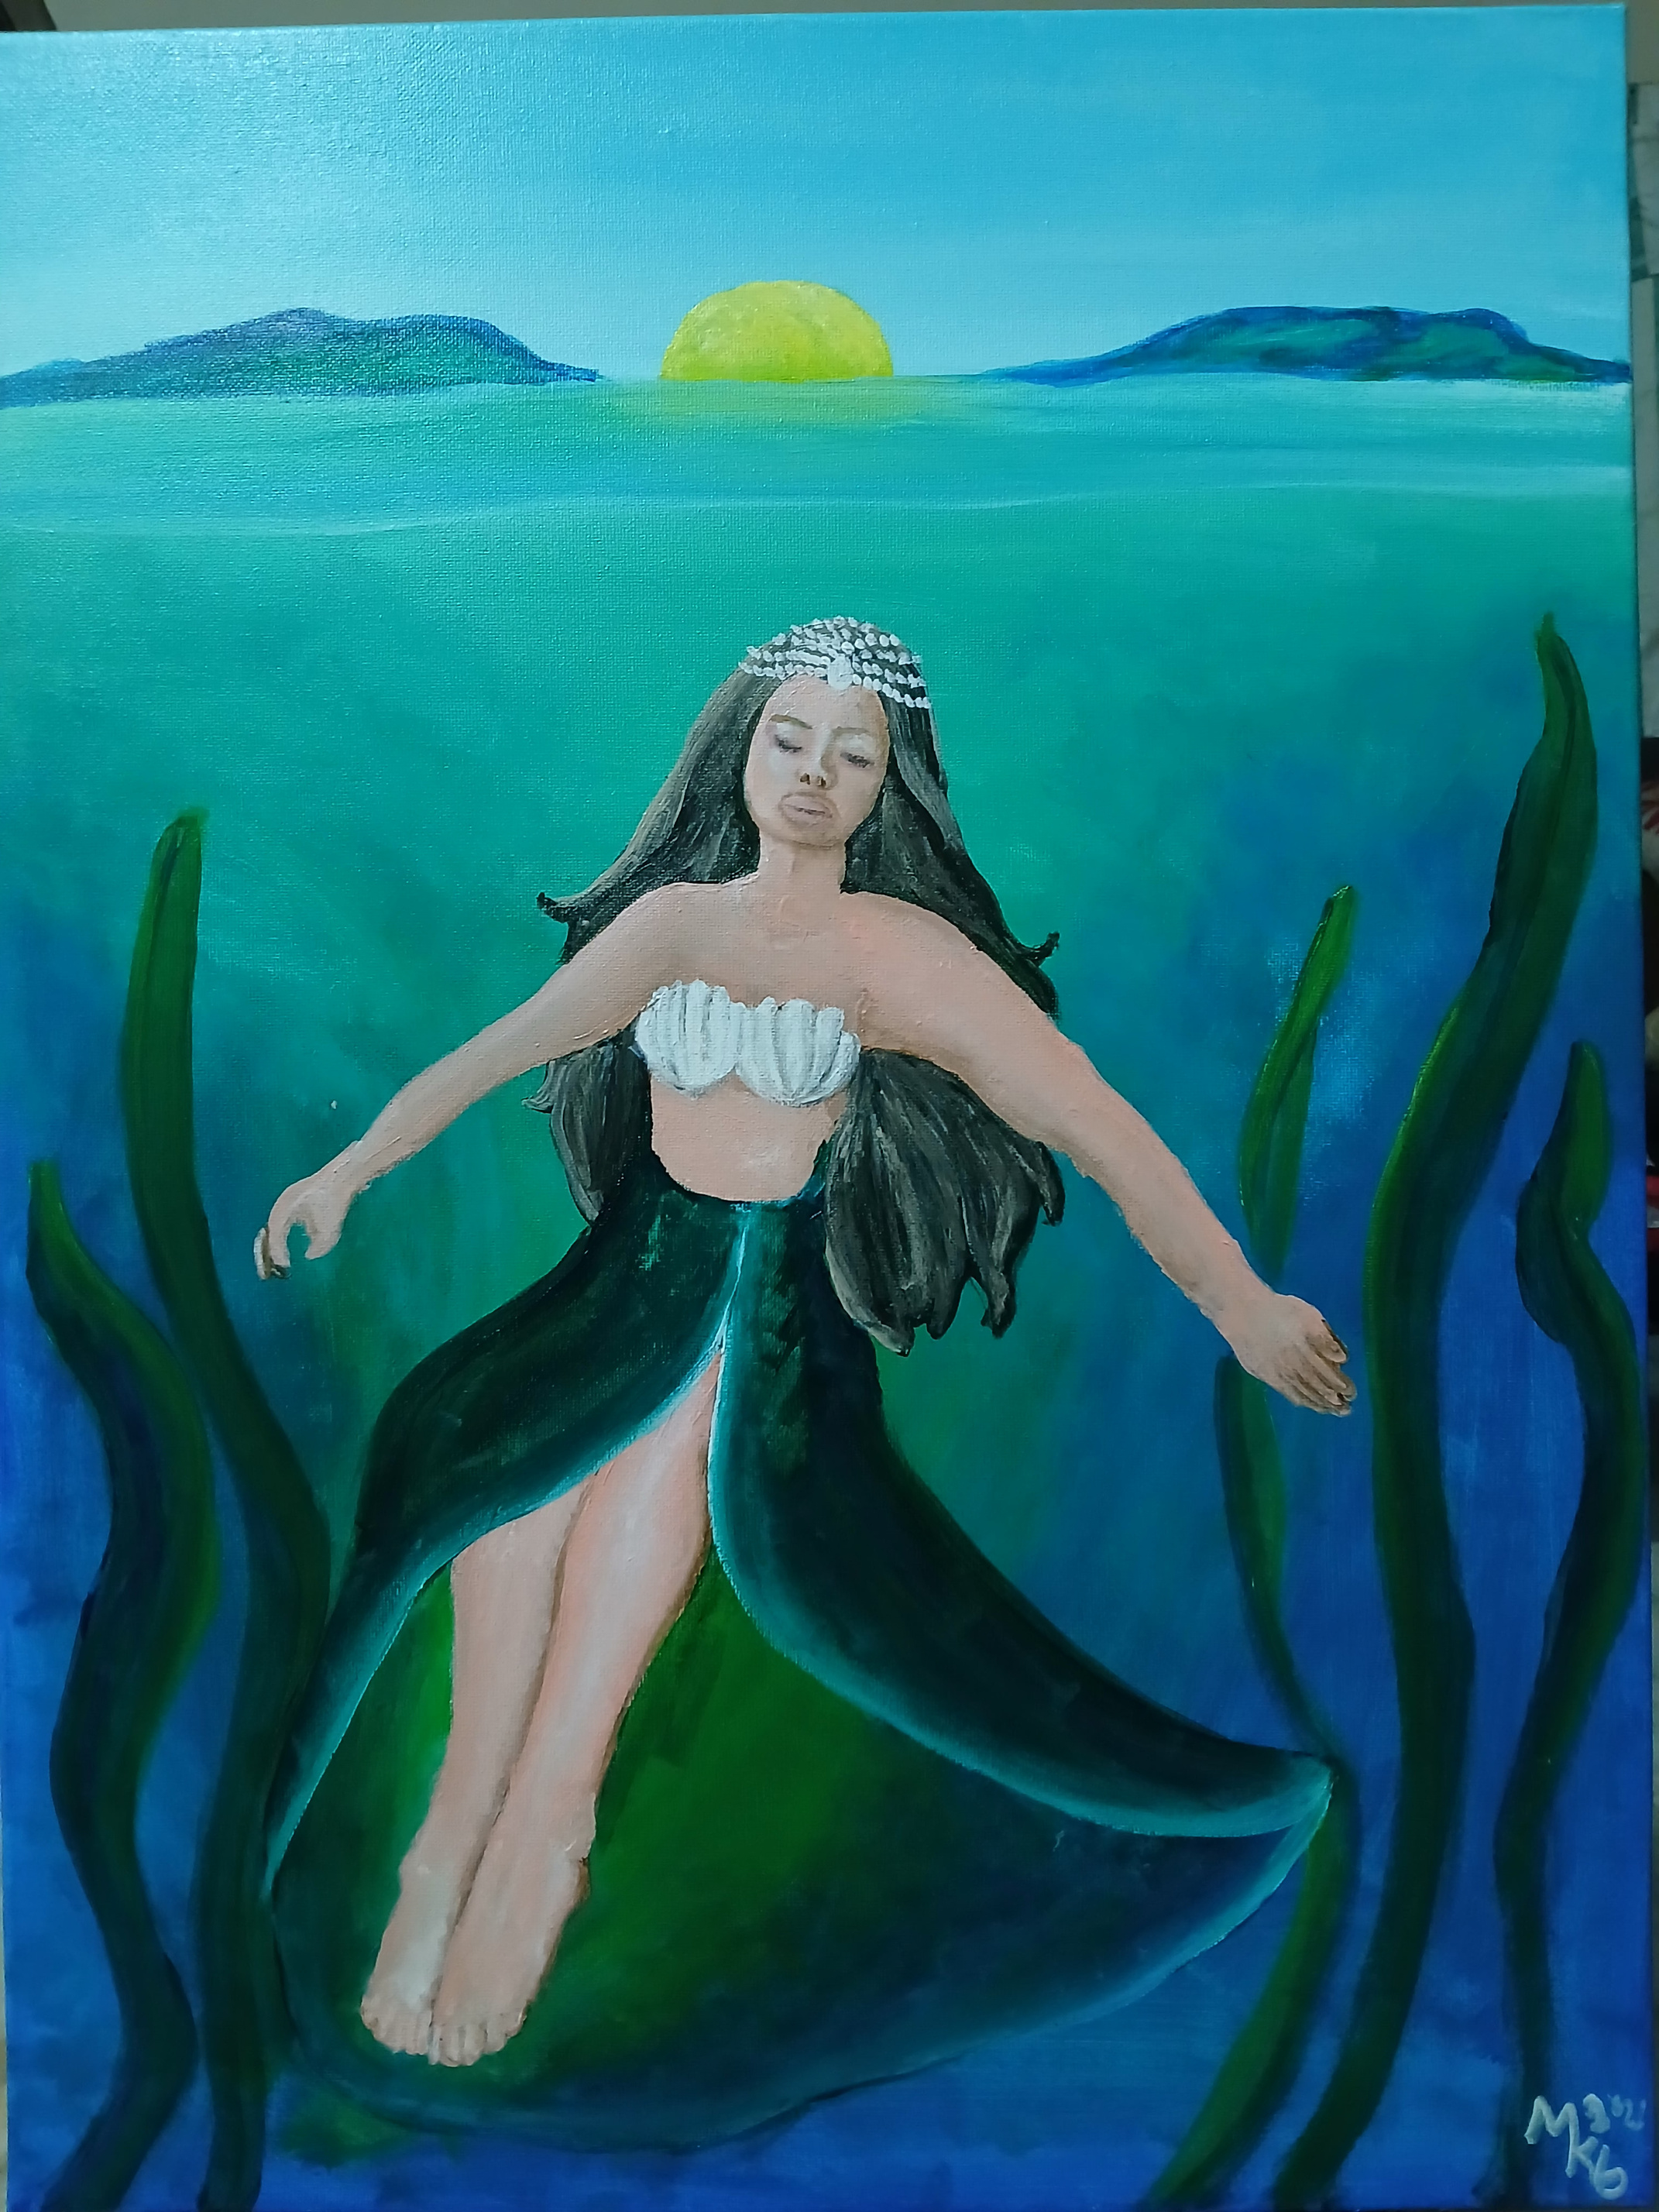
TITTLE: Aman Sinaya
Size: 18inches x 24 inches
Medium: acrylic on canvas
The paintings was about Aman Sinaya. She was one of Primodial Gods and Goddesses on Southern tagalog and Goddess of Sea and Fishermen. I dedicated this painting for our fishermen.

